Product Types:

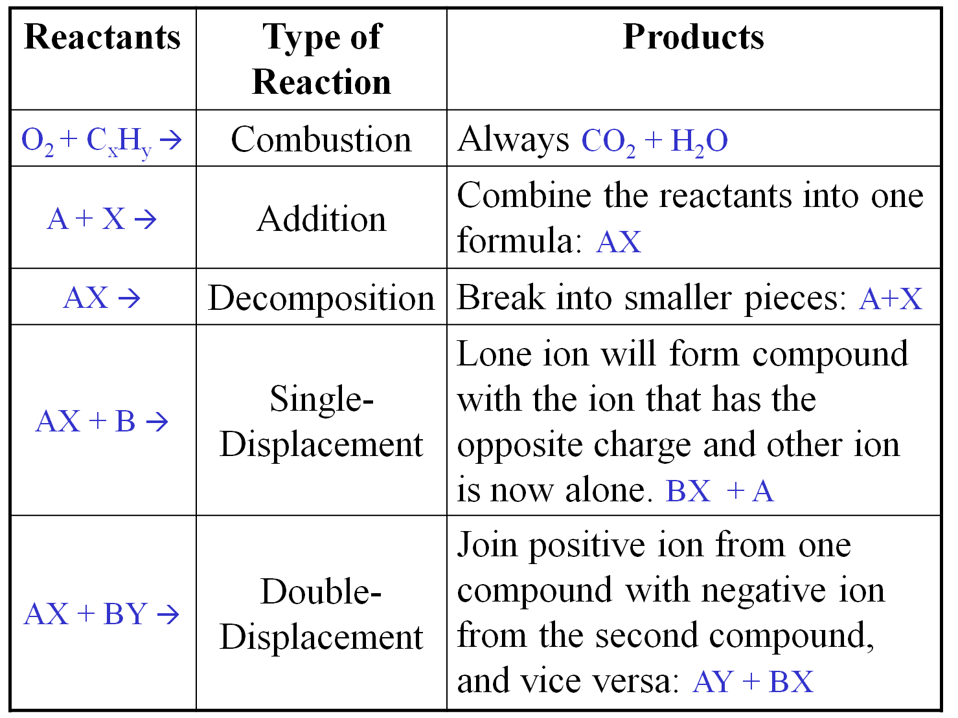

Oxidation Numbers (charges):

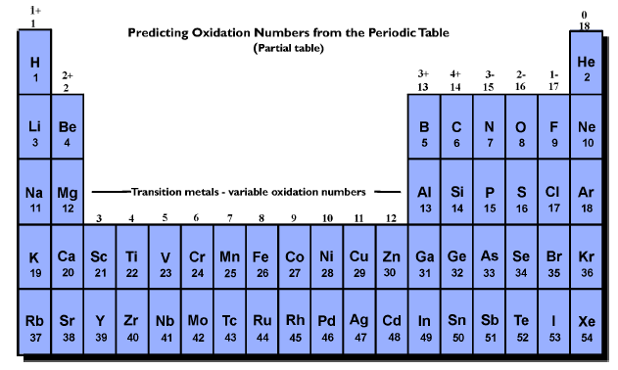

Steps to Writing Chemical Formulas:

- Write positive ion first
- Write negative ion second
- Add the oxidation numbers
  - If they equal zero, then you are done
  - If they don’t equal zero, then figure out how many of each you need (“making the charges balance” or “Criss-Cross Method”)
- move the charge of one atom and make it the subscript for the other
Examples:

Polyatomic Ions to Know:

CO₃⁻² carbonate
SO₄⁻² sulfate
- Treat polyatomic ions as a group.
- Remember that the charge is for the WHOLE GROUP together.
- Use parenthesis if there is more than 1!
SCN⁻¹ thiocyanate
NO₃⁻¹ nitrate
PO₄⁻³ phosphate
NH₄⁺ ammonium
OH⁻¹ hydroxide
C₂H₃O₂⁻¹ acetate
CrO₄⁻² chromate
MnO₄⁻¹ permanganate

Example: Be + NO₃

Practice Compounds to Create:

1. K and Se ____________

2. Na and OH ____________
3. NH₄ and S ____________

4. C₂H₃O and Li ___________
5. CO₃ and Ga ____________

6. PO₄ and Na ____________

