Oxidation Numbers (charges):

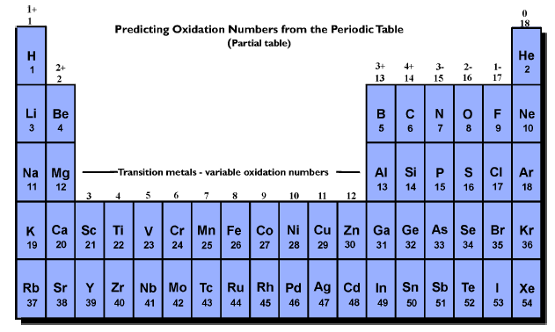

Ionic Compounds - one metal and one non-metal

Steps to Writing Chemical Formulas:

- Write positive ion first
- Write negative ion second
- Add the oxidation numbers
  - If they equal zero, then you are done
  - If they don’t equal zero, then figure out how many of each you need (“making the charges balance” or “Criss-Cross Method”)
- move the charge of one atom and make it the subscript for the other

Practice Compounds to Create:

1. K and Se ____________

2. Na and OH ____________
3. NH₄ and S ____________

4. C₂H₃O₂ and Li ___________
5. CO₃ and Ga ____________

6. PO₄ and Na ____________

